NASA App
Flask Backend — Code Documentation
Lab 7 | Free NASA API | Python Flask | Jupyter Notebook

1. Project Overview
This is a Flask-based backend application that connects to the NASA public API and provides space-related data through simple URL endpoints. The app is built for Lab 7 and runs inside a Jupyter Notebook using threading to avoid conflicts.

Item | Detail
Lab | Lab 7 — Flask Backend App
App Type | NASA Information App
Backend | Python Flask
API Used | NASA Open API (api.nasa.gov)
API Key | DEMO_KEY (free, no signup needed)
Run Method | Threading (for Jupyter Notebook compatibility)
Port | 5000 — http://127.0.0.1:5000

2. API Endpoints
The app has 4 endpoints. Open these URLs in your browser after running the cell:

Endpoint | Method | What It Returns
/ | GET | Welcome message and list of all available endpoints
/apod | GET | Today's Astronomy Picture of the Day from NASA
/apod?date=YYYY-MM-DD | GET | APOD for a specific date (e.g. /apod?date=2024-01-15)
/neo | GET | Top 5 Near Earth Asteroids passing by today
/mars | GET | 5 photos taken by Mars Curiosity Rover on Sol 1000

3. Complete Code
from flask import Flask, jsonify, request
import requests
import threading

app = Flask(__name__)

NASA_API_KEY = "DEMO_KEY"
NASA_APOD_URL = "https://api.nasa.gov/planetary/apod"
NASA_NEO_URL = "https://api.nasa.gov/neo/rest/v1/feed"
NASA_MARS_URL = "https://api.nasa.gov/mars-photos/api/v1/rovers/curiosity/photos"

@app.route("/")
def home():
return jsonify({
"message": "Welcome to NASA App",
"endpoints": [
"/apod - Astronomy Picture of the Day",
"/apod?date=YYYY-MM-DD - APOD for a specific date",
"/neo - Near Earth Objects (today)",
"/mars - Mars Rover Photos"
]
})

@app.route("/apod")
def apod():
date = request.args.get("date", "")
params = {"api_key": NASA_API_KEY}
if date:
params["date"] = date
response = requests.get(NASA_APOD_URL, params=params)
data = response.json()
return jsonify({
"title": data.get("title"),
"date": data.get("date"),
"explanation": data.get("explanation"),
"url": data.get("url"),
"media_type": data.get("media_type")
})

@app.route("/neo")
def neo():
from datetime import date
today = str(date.today())
params = {"start_date": today, "end_date": today, "api_key": NASA_API_KEY}
response = requests.get(NASA_NEO_URL, params=params)
data = response.json()
asteroids = data.get("near_earth_objects", {}).get(today, [])
result = []
for asteroid in asteroids[:5]:
result.append({
"name": asteroid["name"],
"diameter_km": asteroid["estimated_diameter"]["kilometers"]["estimated_diameter_max"],
"is_hazardous": asteroid["is_potentially_hazardous_asteroid"],
"close_approach": asteroid["close_approach_data"][0]["close_approach_date"],
"miss_distance_km": asteroid["close_approach_data"][0]["miss_distance"]["kilometers"]
})
return jsonify({"date": today, "asteroids": result})

@app.route("/mars")
def mars():
params = {"sol": 1000, "api_key": NASA_API_KEY}
response = requests.get(NASA_MARS_URL, params=params)
data = response.json()
photos = data.get("photos", [])[:5]
result = []
for photo in photos:
result.append({
"id": photo["id"],
"sol": photo["sol"],
"camera": photo["camera"]["full_name"],
"earth_date": photo["earth_date"],
"image_url": photo["img_src"]
})
return jsonify({"rover": "Curiosity", "photos": result})

def run_app():
app.run(debug=False, port=5000, use_reloader=False)

thread = threading.Thread(target=run_app)
thread.daemon = True
thread.start()

print("Flask server is running at: http://127.0.0.1:5000")

Output screenshot :

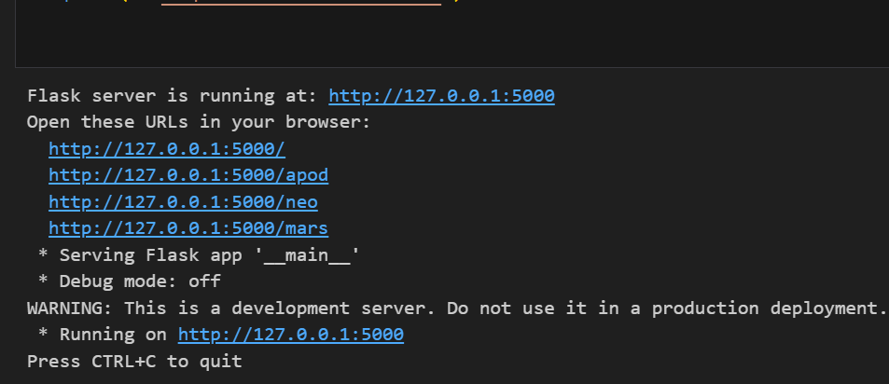

4. Line-by-Line Explanation

Part 1 — Imports & App Setup
from flask import Flask, jsonify, request
import requests
import threading
app = Flask(__name__)

- Flask — the web framework used to create the backend server
- jsonify — converts Python dictionaries into JSON format for the API response
- request — used to read URL parameters like ?date=2024-01-01
- requests — used to call the NASA API from our code (external HTTP calls)
- threading — allows Flask to run in the background inside Jupyter Notebook
- app = Flask(__name__) — creates the Flask application instance

Part 2 — NASA API Configuration
NASA_API_KEY = "DEMO_KEY"
NASA_APOD_URL = "https://api.nasa.gov/planetary/apod"
NASA_NEO_URL = "https://api.nasa.gov/neo/rest/v1/feed"
NASA_MARS_URL = "https://api.nasa.gov/mars-photos/api/v1/rovers/curiosity/photos"

- NASA_API_KEY — DEMO_KEY is a free key provided by NASA — no registration needed but has limited requests per hour
- NASA_APOD_URL — endpoint for Astronomy Picture of the Day
- NASA_NEO_URL — endpoint for Near Earth Objects (asteroids)
- NASA_MARS_URL — endpoint for Mars Curiosity Rover photos

Part 3 — Home Route ( / )
@app.route("/")
def home():
return jsonify({"message": "Welcome to NASA App", "endpoints": [...]})

- @app.route("/") — decorator that tells Flask: when someone visits the root URL, run this function
- jsonify(...) — returns a JSON response with a welcome message and list of all available endpoints

Part 4 — APOD Route ( /apod )
@app.route("/apod")
def apod():
date = request.args.get("date", "")
params = {"api_key": NASA_API_KEY}
if date:
params["date"] = date
response = requests.get(NASA_APOD_URL, params=params)
data = response.json()
return jsonify({"title": ..., "date": ..., "explanation": ..., "url": ...})

- request.args.get("date", "") — reads the optional ?date= parameter from the URL — if not given, defaults to empty string
- params = {"api_key": NASA_API_KEY} — starts building the query parameters for the NASA API call
- if date: params["date"] = date — only adds the date parameter if the user provided one
- requests.get(NASA_APOD_URL, params=params) — calls the NASA API with the parameters
- response.json() — converts the API response into a Python dictionary
- data.get("title") — safely extracts the title field — returns None if not found

Part 5 — NEO Route ( /neo )
@app.route("/neo")
def neo():
from datetime import date
today = str(date.today())
params = {"start_date": today, "end_date": today, "api_key": NASA_API_KEY}
asteroids = data.get("near_earth_objects", {}).get(today, [])
for asteroid in asteroids[:5]:
result.append({"name": ..., "diameter_km": ..., "is_hazardous": ...})

- date.today() — gets today's date automatically
- start_date and end_date both = today — fetches only today's asteroids
- asteroids[:5] — limits results to top 5 asteroids so the response is not too long
- is_potentially_hazardous_asteroid — NASA flag — True means the asteroid could potentially be dangerous
- miss_distance km — how far the asteroid will pass from Earth in kilometers

Part 6 — Mars Route ( /mars )
@app.route("/mars")
def mars():
params = {"sol": 1000, "api_key": NASA_API_KEY}
photos = data.get("photos", [])[:5]
for photo in photos:
result.append({"id": ..., "camera": ..., "earth_date": ..., "image_url": ...})

- sol = 1000 — Sol is a Martian day. Sol 1000 means the 1000th day of the Curiosity rover's mission on Mars
- photos[:5] — returns only 5 photos to keep the response clean
- camera full_name — name of the camera used to take the photo (e.g. Front Hazard Avoidance Camera)
- img_src — direct URL to view the actual Mars photo

Part 7 — Threading (Jupyter Fix)
def run_app():
app.run(debug=False, port=5000, use_reloader=False)

thread = threading.Thread(target=run_app)
thread.daemon = True
thread.start()

- Why threading? — Jupyter Notebook has its own event loop. Calling app.run() directly causes SystemExit error. Threading runs Flask in the background so Jupyter keeps working normally
- debug=False — debug mode must be off when using threading — otherwise it causes conflicts
- use_reloader=False — disables Flask's auto-reloader which does not work inside Jupyter
- thread.daemon = True — when Jupyter shuts down, this thread automatically stops too — no cleanup needed
- thread.start() — launches the Flask server in the background

5. How to Run the App
Step | Action
1 | Open NASA_App_Fixed.ipynb in Jupyter Notebook
2 | Click Run on the cell (Shift + Enter)
3 | Wait for: 'Flask server is running at http://127.0.0.1:5000'
4 | Open your browser and go to http://127.0.0.1:5000/apod
5 | You will see NASA data in JSON format

6. Code Summary
Part | What It Does
Flask, jsonify, request | Core Flask imports for routing and JSON responses
requests library | Calls the NASA API from Python
threading | Runs Flask in background — fixes Jupyter SystemExit error
NASA_API_KEY = DEMO_KEY | Free NASA API key — no registration required
/ route | Home page — shows all available endpoints
/apod route | Returns today's NASA Astronomy Picture of the Day
/apod?date= route | Returns APOD for any specific date
/neo route | Returns 5 Near Earth asteroids passing by today
/mars route | Returns 5 Mars Curiosity Rover photos from Sol 1000
thread.daemon = True | Auto-stops the server when Jupyter closes

NASA App | Lab 7 | Flask Backend Documentation

